

**PLANTS PALACE**

**Table of content**

1. Problem Definition.
2. Customer Requirement.
3. Project plan.
4. Facility.
5. Task sheet.
6. Project Review and Monitoring Report.
7. User Guide.



**PLANTS PALACE**

**Problem Statement**

**Plant Palace** has made significant efforts to provide world-class facilities and infrastructure to promote its extensive range of plant products. Over time, **Plant Palace** has emerged as one of the leading providers in the country for a wide variety of plants, including indoor and outdoor plants, succulents, herbs, and ornamental plants, while also making strides toward establishing a formidable international presence. The company offers services such as "Free Shipping" and "Fast Delivery." To present all this information in an organized manner, a well-structured website is required.

**Customer Requirement**

1. The Home Page with some description about the Products with proper way and smooth.
2. The link facilities like :
   1. Free shipping
   2. Fast delivery
   3. All products are available
3. List of the products arranged with details.
4. Suggestion and complaints
5. Feedback
6. Information are mention for each type of products
7. There more information about plants



**PLANTS PALACE**

**Project plan**

1. At first we analyzed the project, took ideas about plants and types of.
2. We decided to made first a home page with some products and info.
3. I also had to make a User guide.

**Facility**

We provide a lot’s of facilities in our plants website

Free shipping

All products are available

Fast delivery

**Group Member**

* **Muhammad Mudasir**
* **Syed Zaki Haider**
* **Neha**

**Project Requirement**

1.Design the UI for the PlantPalace Website, including the

catalog display, search bar, sorting options, and plant

information section.

2. Create necessary components and services to display

the plant catalog, handle search, sorting, and filtering

operations.

3. Implement the shopping cart

(adding/modifying/deleting item) basic functionalities.

4.Optionally, use REST APIs if you are well-versed with

them.

5.Test the Website's functionality, including browsing,

searching, adding items to the cart, and placing orders.

Deploy the Website to a local Web server such as

XAMPP for testing purposes.



**PLANTS PALCE**

**User guide**

**Home page**

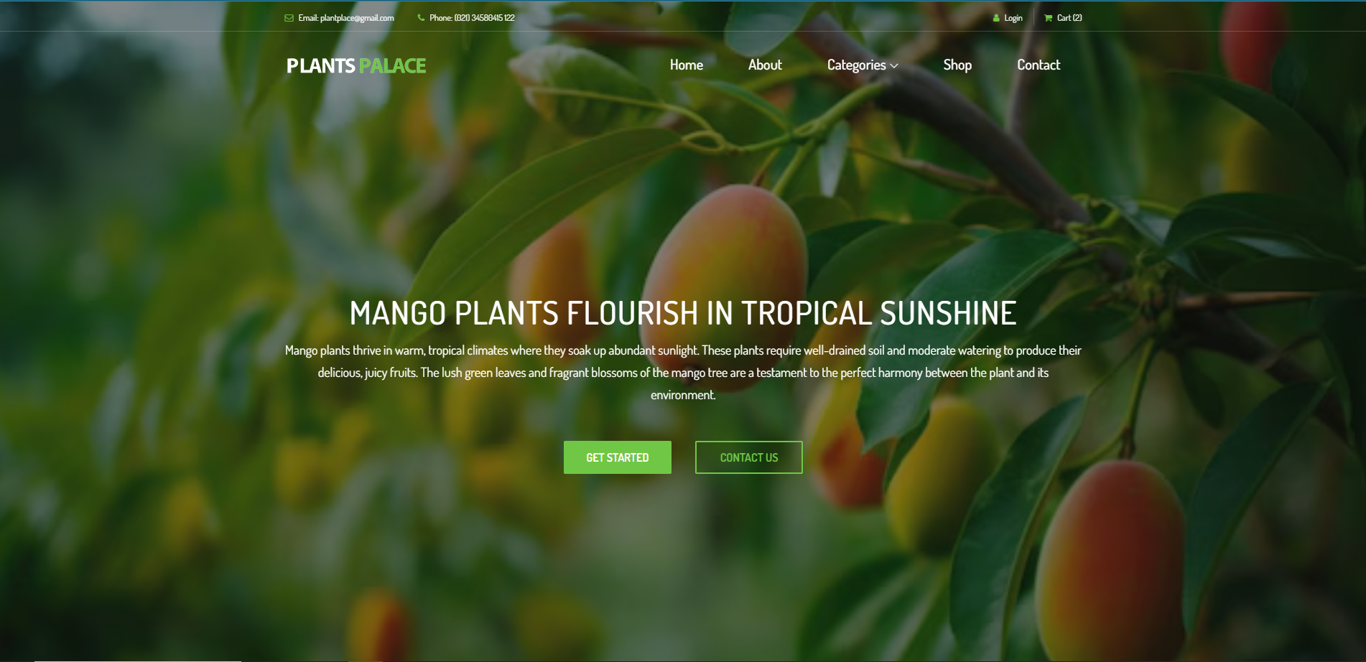

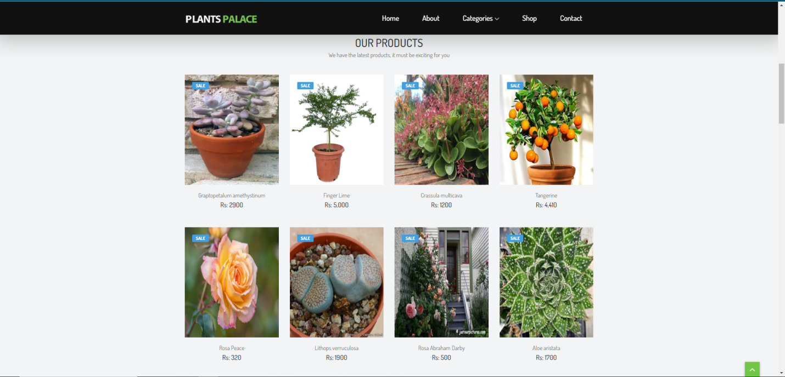

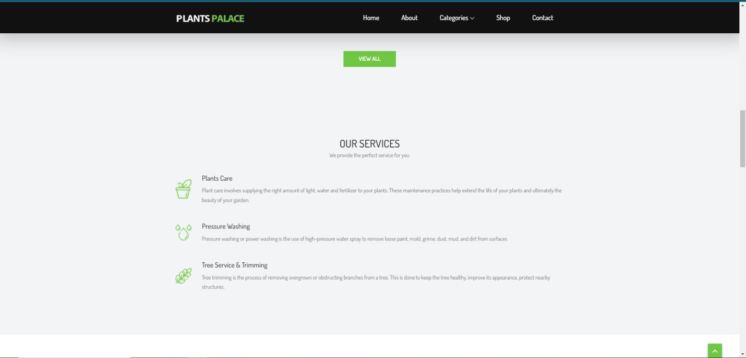

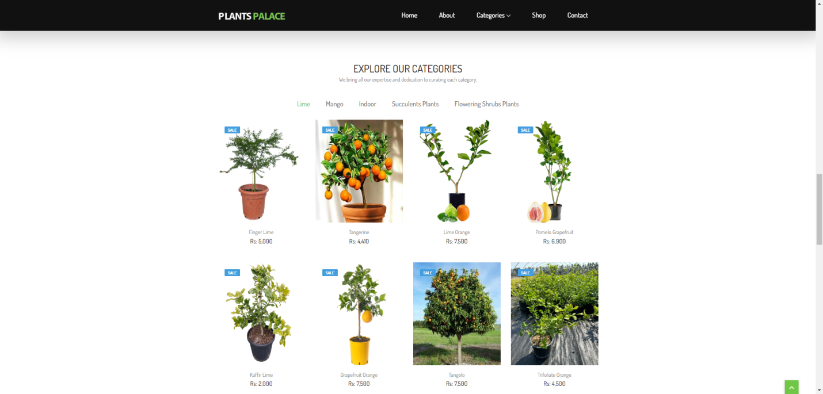

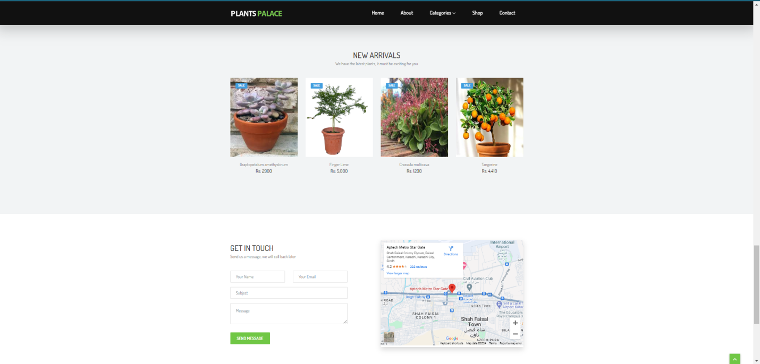

**Footer page**

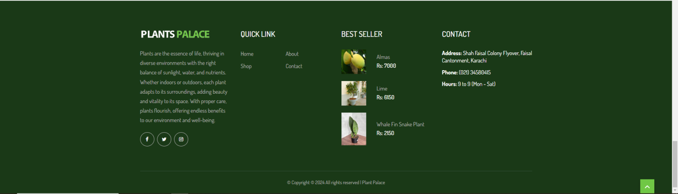

Categories Page

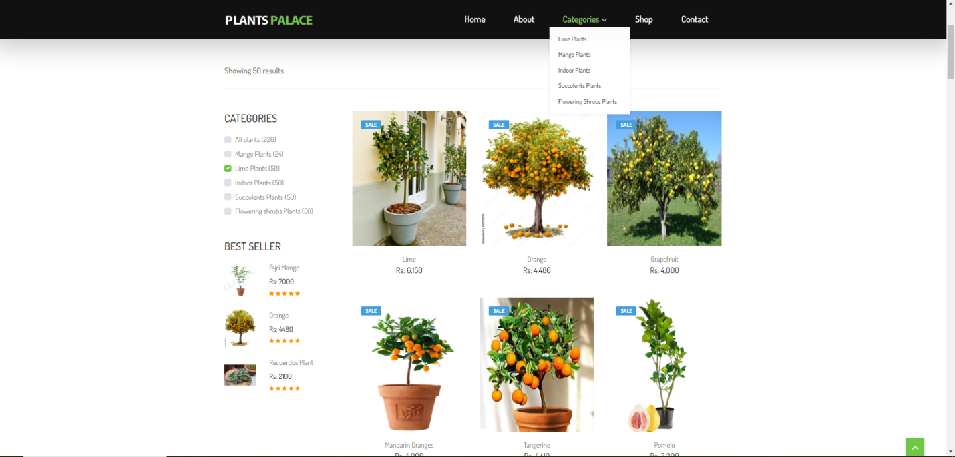

About Page

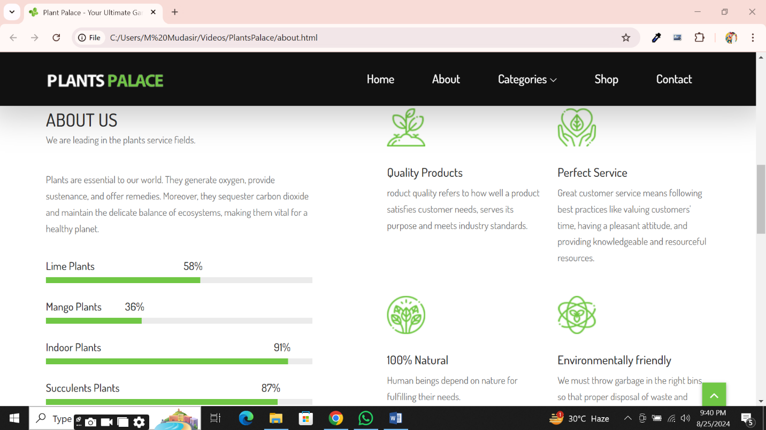

Shop Page

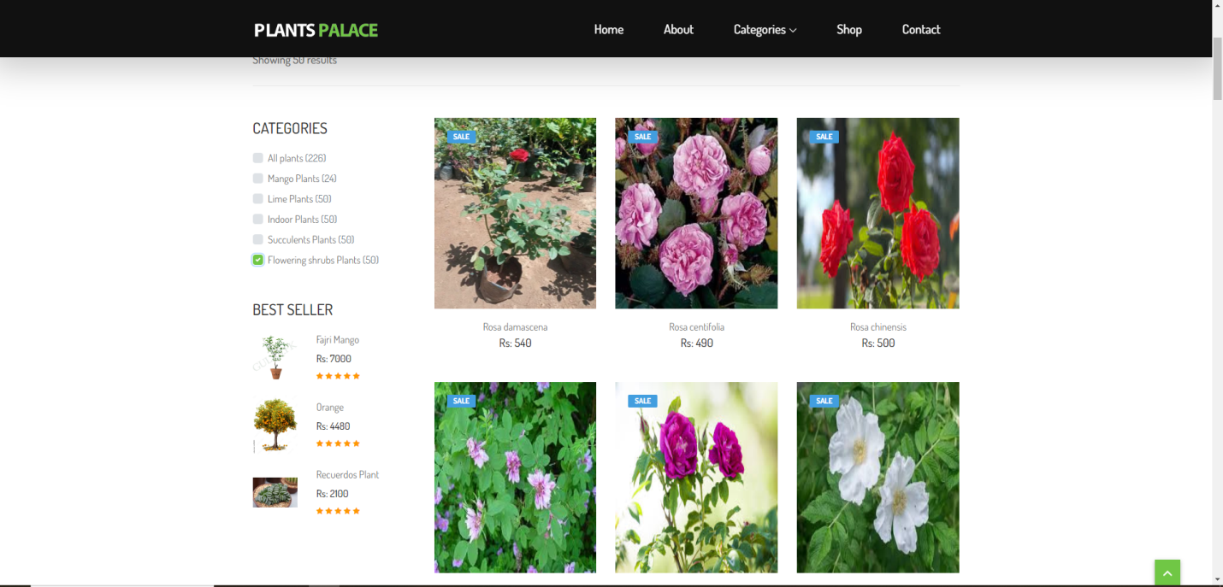

Contact Page

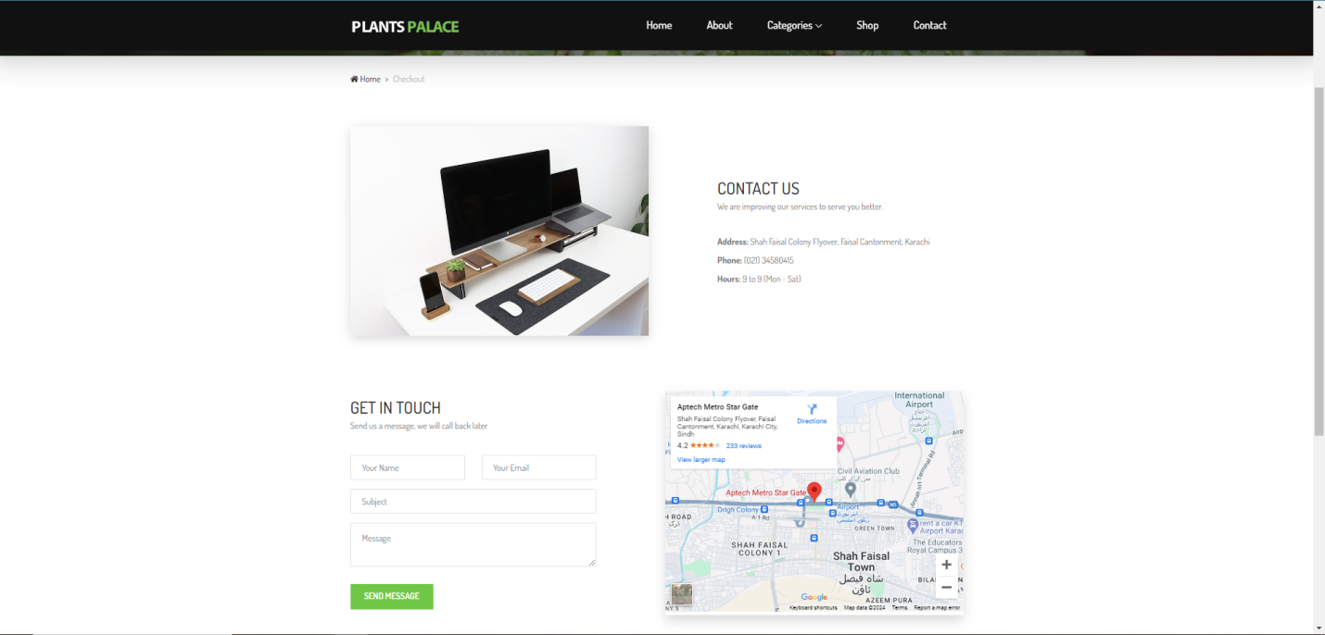



**PLANTS PALACE**

Thank You